A) User Manual Procedure

Setting Up a GitHub Repository and Making a First Commit

Prerequisites
Before starting, make sure you have:
- A GitHub account.
- Git installed on your computer.
- Visual Studio Code (VS Code) installed.
- An internet connection.
- Basic computer literacy.

Procedure
Step 1: Create a project folder
Create a new folder named github-first-commit in your Documents folder.
Expected result: A folder named github-first-commit is created.
Step 2: Open the project folder in VS Code
Open the github-first-commit folder in Visual Studio Code.
Expected result: The empty github-first-commit folder appears in the VS Code Explorer.
Step 3: Create the README file
Create a new file named README.md inside the project folder.
Expected result: README.md appears in the VS Code Explorer.
Step 4: Add content to the README file
Type # My First GitHub Repository into README.md.
Expected result: The text appears in the README file.
Step 5: Save the README file
Press Ctrl + S to save the file.
Expected result: The changes to README.md are saved.
Step 6: Open the VS Code terminal
Open Terminal → New Terminal in VS Code.
Expected result: A terminal panel appears at the bottom of VS Code.
Step 7: Initialize the Git repository
Run git init in the terminal.
Expected result: Git creates a local repository inside the project folder.
Step 8: Check the repository status
Run git status in the terminal.
Expected result: Git shows README.md as an untracked file.
Step 9: Stage the README file
Run git add README.md in the terminal.
Expected result: README.md is added to the staging area.
Step 10: Create the first commit
Run git commit -m "Initial commit" in the terminal.
Expected result: Git creates the first commit and confirms that the commit was created.
Step 11: Create a GitHub repository
Create a new GitHub repository named github-first-commit.
Expected result: GitHub creates an empty repository named github-first-commit.
Step 12: Copy the repository URL
Copy the HTTPS URL of the new GitHub repository.
Expected result: The repository URL is copied to the clipboard.
Step 13: Connect the local repository to GitHub
Run git remote add origin <repository-URL> in the terminal, replacing <repository-URL> with the copied GitHub URL.
Expected result: The local Git repository is connected to the GitHub repository.
Step 14: Rename the branch to main
Run git branch -M main in the terminal.
Expected result: The current branch is renamed to main.
Step 15: Push the commit to GitHub
Run git push -u origin main in the terminal.
Expected result: The main branch and the committed README.md file are uploaded to GitHub.
Step 16: Verify the GitHub repository
Refresh the GitHub repository page.
Expected result: The repository displays README.md, the main branch, and the Initial commit.

Screenshot Description
Include a screenshot of the completed GitHub repository page. The screenshot shows the repository name github-first-commit, the main branch, the README.md file, and the Initial commit.
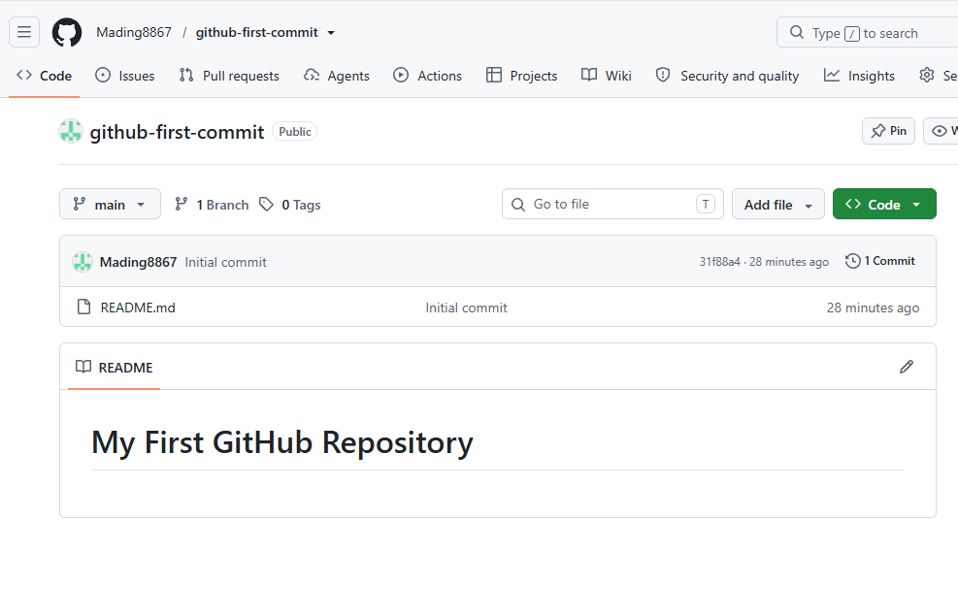

Troubleshooting
Problem: git is not recognized as a command.
This error usually means that Git is not installed or Git was not added to the system PATH. Install Git, restart VS Code, and try the command again.

B) API Reference Entry

Create a New Task

Endpoint
Method: POST
Path: /api/v1/projects/{projectId}/tasks

Description
This endpoint creates a new task in a specific project. The user must be authenticated before creating a task.

Path Parameters
Parameter | Type | Required | Description
projectId | integer | Yes | The unique ID of the project where the task will be created.

Request Headers
Header | Required | Description
Authorization | Yes | Contains the user's authentication token in the format Bearer <token>.
Content-Type | Yes | Must be application/json.

Request Body Parameters
Parameter | Type | Required | Description
title | string | Yes | The name of the task.
description | string | No | Additional information about the task.
assigneeId | integer | Yes | The unique ID of the user assigned to the task.
dueDate | string | Yes | The date when the task is due, using the YYYY-MM-DD format.
priority | string | Yes | The priority of the task. Allowed values are low, medium, or high.

Example Request
POST /api/v1/projects/42/tasks
Authorization: Bearer eyJhbGciOi...
Content-Type: application/json

{
"title": "Complete project documentation",
"description": "Finish and review the technical documentation for the project.",
"assigneeId": 25,
"dueDate": "2026-10-15",
"priority": "high"
}

Response Codes
Status Code | Description
201 Created | The task was successfully created.
400 Bad Request | The request contains invalid or missing data.
401 Unauthorized | The authentication token is missing or invalid.
403 Forbidden | The user is authenticated but does not have permission to create a task in the project.
404 Not Found | The specified project or assignee does not exist.
409 Conflict | The request conflicts with an existing task or project rule.
500 Internal Server Error | The server encountered an unexpected error while processing the request.

Example Successful Response
{
"id": 1087,
"projectId": 42,
"title": "Complete project documentation",
"description": "Finish and review the technical documentation for the project.",
"assigneeId": 25,
"dueDate": "2026-10-15",
"priority": "high",
"status": "pending",
"createdAt": "2026-10-07T14:30:00Z"
}

C) Technical Report Section

GitHub Repository Setup
A GitHub repository was created to store and manage the project files using version control. The project was initialized as a local Git repository, and a README.md file was created to provide basic project information. The file was staged and committed using Git before the local repository was connected to the remote GitHub repository.
The local repository was then renamed to use the main branch and pushed to GitHub. The repository was successfully verified after the push, with the README.md file and the initial commit visible on GitHub.
The procedure demonstrated the basic workflow of creating a local Git repository, recording changes with a commit, connecting the repository to GitHub, and synchronizing the local project with the remote repository.

